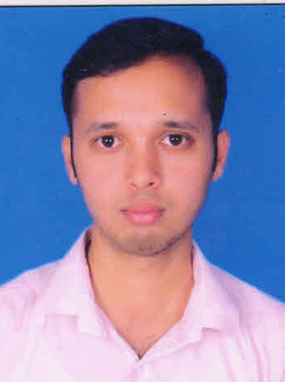
RESUME

SULTAN MOHI UDDIN KHAN
9-125/102/1,
Dream city, Landline No: +914065403296
Balapur Mobile no: +91-9296053552
Rangareddy dist, Email id: ivmasqkhan@gmail.com
Hyderabad- 53. Skype id: sultankhan1988

OBJECTIVE:
Seeking a challenging position to utilize my skills and abilities that gives me a scope to improve my knowledge in accordance with the latest trends and be a part of team that dynamically works towards the growth of the organization.
WORK EXPERIENCE:
EXPERIENCE | COMPANY NAME | LOCATION | DURATION
3 YEARES 11 MONTHS | YASHODA HOSPITAL | MALAKPET HYD | NOV 2012 TO TILL DATE
6 MONTHS | UDAI CLINIC | NAMPALLY HYD | MAY 2012 TO NOV 2012
3 MONTHS | M.N-AREA HOSPITAL | MALAKPET HYD | OCT 2011 TO FEB 2012

EDUCATIONAL QUALIFICATION:
COURSE/YEAR OF PASSING | SCHOOL/COLLEGE | BOARD/UNIVERSITY | PERCENTAGE
D.pharmacy (2012) | Government polytechnic college, Masab tank | State Board of Technical Education And Training,AP. | 62%
Intermediate (2006) | Navya junior college,board of intermediate | Board of Intermediate Education | 63%
SSC (2004) | sacred heart high school | Board of secondary education | 65%
SKILL SET:Operating System: WINDOWS 98/XP/2000 PROFEESIONAL
Package: MS OFFICE

JOB PROFILE:
- Dispensing the medication according to the doctor’s prescription at OP.
- Dispensing the medication according to the indents raised from wards at IP.
- Daily online indenting the required stock and receiving the stock.
- Ordering of implants used to the vender and replacing the implants.
- Daily checking of the stocks and maintain the records.
- Maintaining the narcotic drugs register being used in Operation Theater.
- Ordering of the shortage medicines.
- Billing of the medicines dispensed.
- Dispensing of the post-operative medicines to Inpatients.
PERSONAL DETAILS:
NAME: Sultan Mohi Uddin Khan
FATHER’S NAME: Moiz Uddin Khan
GENDER: Male
DATE OF BIRTH: 20/09/1988.
MARITAL STATUS: Unmarried
.HOBBIES: Playing Carom & Cricket.
Passport no:k7641033,expiry:03/02/2023
DECLARATION:
I hereby declare that the information furnished above is true as far as I am concern.
Date:
Place: Hyderabad (SULTAN MOHI UDDIN KHAN)

